Exp. 21 SQL Storage Service

Aim:
To create a SQL storage service and perform a basic query using any Public Cloud Service Provider (Azure/GCP/AWS) to demonstrate Database as a Service (DaaS)
Procedure:
- Sign in to Azure Portal
- Create a resource group
- Create a VM
- Open the VM by entering username and password
- Install MySQL (Server only) inside the VM
- Now the database is ready.
Output:
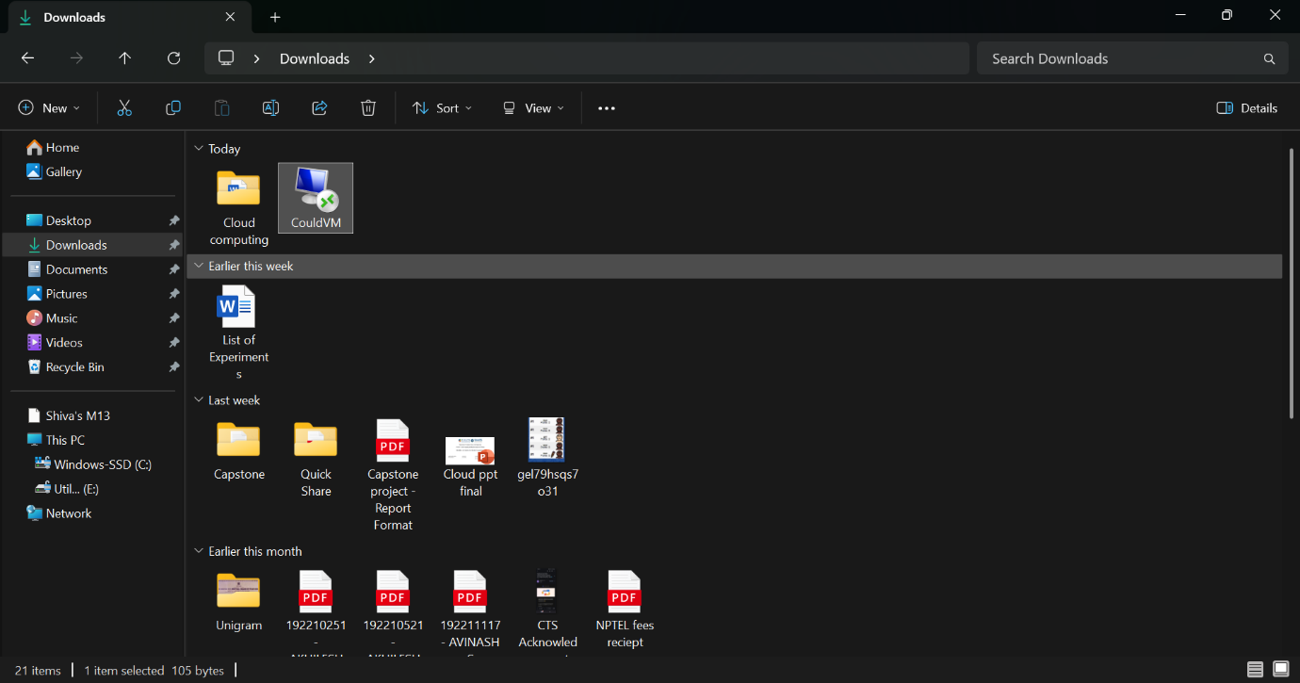
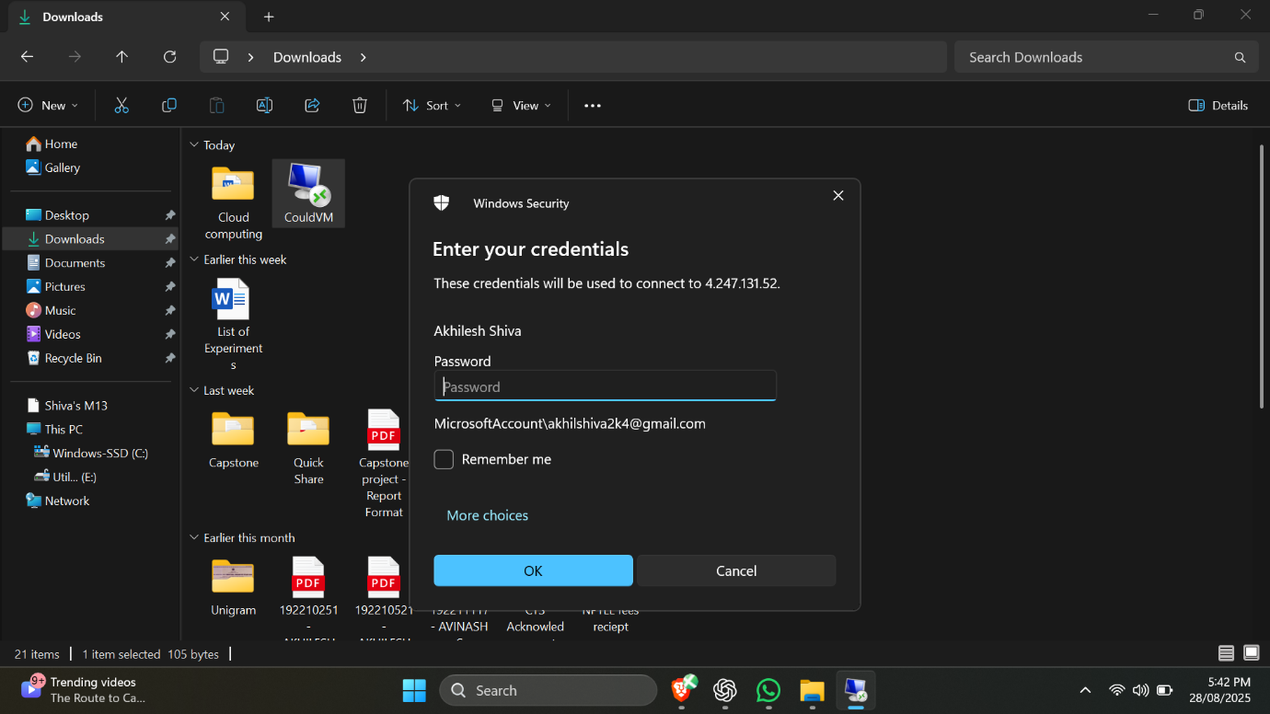
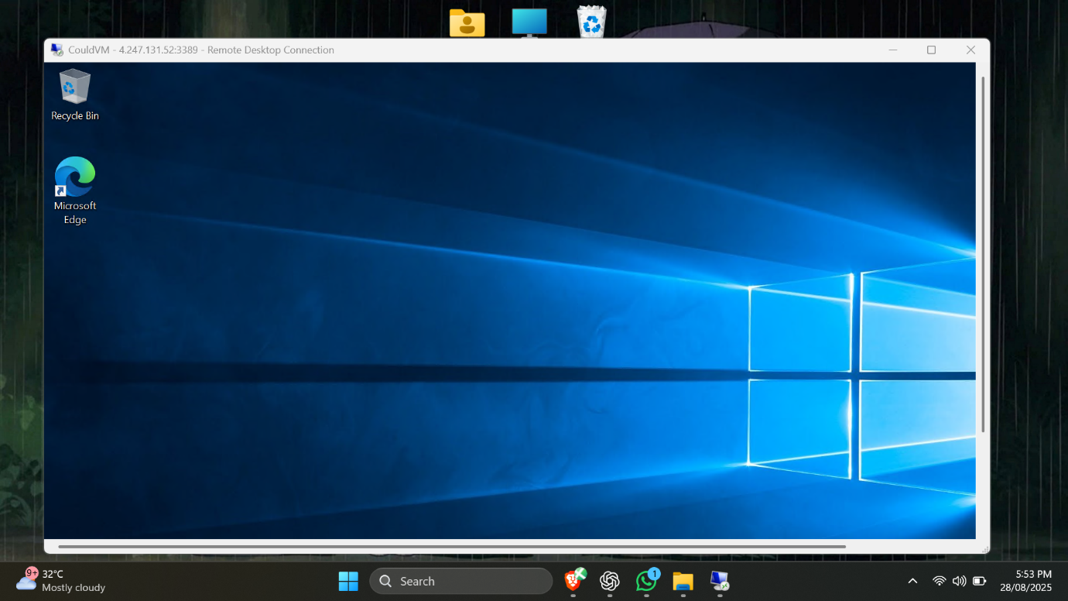
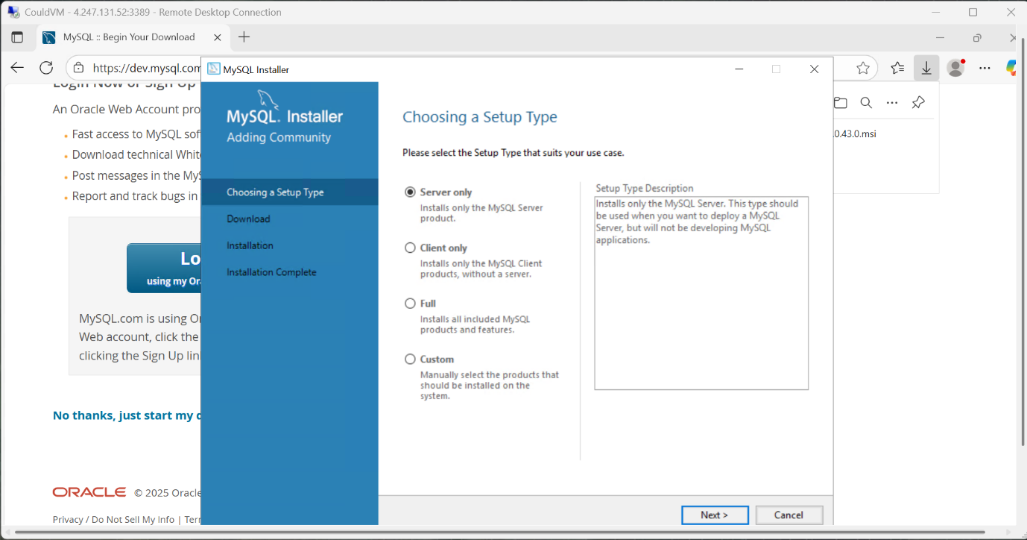
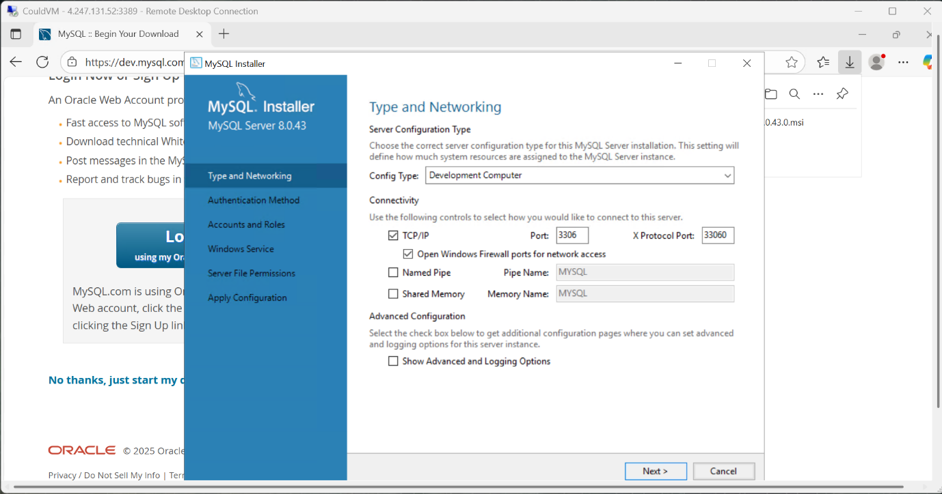
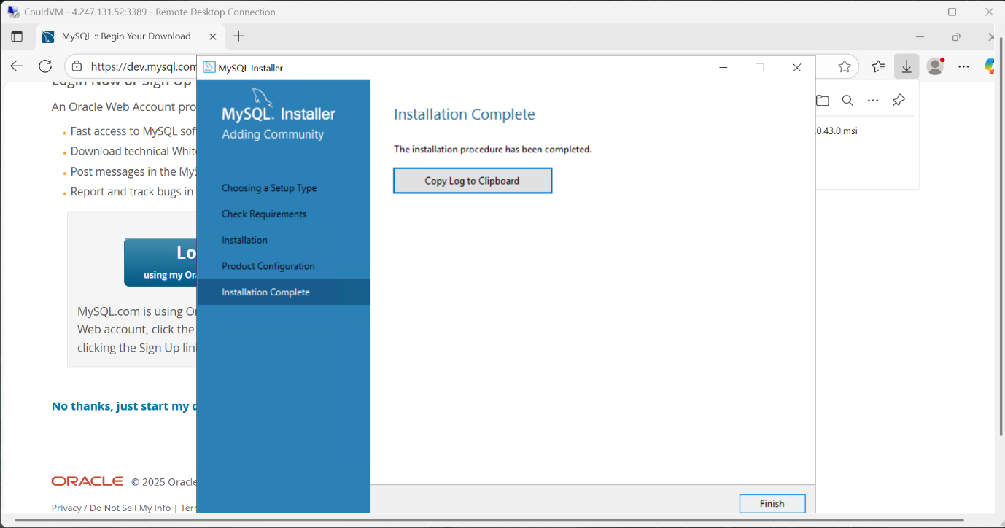
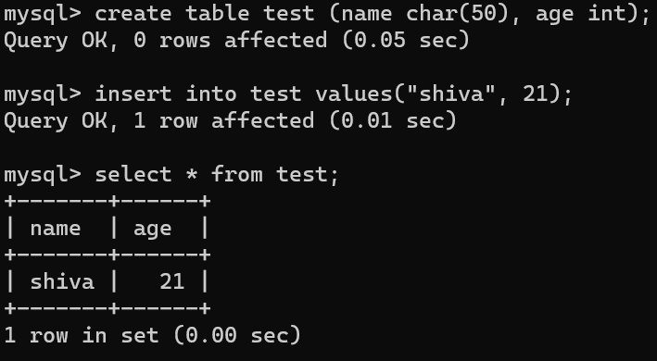

Result:
Thus, a simple query was executed in MySQL in the VM

